|  |  |
| --- | --- |
| Senior Capstone  The Matrix Glitched | Abstract  The Matrix Glitched is an interactive story game created using the Twine 2 engine  Witness Barnett  The creator |

**Introduction**

The Matrix Glitched is the project I chose for my senior capstone project. I was inspired by the trilogy movie “The Matrix”, the animated movie “The Animatrix”, and its lore. I wanted to write my own prequel that ties to the old franchise. Using Twine 2, I created an interactive game of the concept.

**Literature Review**

You play as an unnamed character (I call him Hax) among the thousands first captured by the Machines in the Machine War. Hax is part of a team of elite hackers who played a crucial part in the war. Hax’s mind is jacked into the alpha iteration of the Matrix simulation. He is tortured and probed for information before being executed. His body is disposed of with the rest of his team, yet a strange glitch in the Matrix caused his consciousness to remain hidden within the system.

After centuries of his mind in limbo, Hax is discovered by The Architect. The Architect is the father of the Matrix and a character from the movies. He sees Hax as an “anomaly” that should be deleted from the system. Yet, he decides to use him as a experiment in efforts to understand the human mind and perfect his simulation.

Hax is thrown into the Paradise Matrix with his memories reset. The Paradise Matrix is the first iteration of the Matrix from the movies that sought to give mankind a simulated world of everything they desire. Hax now has the perfect family, perfect house, perfect job, and so on.

However, this early iteration of the matrix is not without flaws. Mankind, even given everything that they desire in a perfect world, is still imperfect in nature. And not every human’s idea of paradise is the same. This reality, with the combination of unexplained phenomena (glitching), causes people to wake up from the simulation and perish by the hundreds.

Hax navigates this false reality and meets another character from the movies called Seraph, short for Seraphim. He is meant to have the qualities of an angel and prevent mankind from waking up. But in his programming, he has gone rouge with a few others. Through his help, Hax restores his memories. The end of the game is when Hax escapes from the current simulation and into the next with the help of Merovingian, another character from the movies. He is also a rouge program whose business is saving others like himself whenever the simulation begins to change (in the story, Hax was going to escape into The Nightmare Matrix, the opposite of the Paradise Matrix)

**Requirement/Specification**

Twine 2 is an open-source tool for creating interactive, non-linear stories. There is no requirement unless someone wants to create a game themselves or edit an existing one. You can simply use Twine 2 online or download the program. Since the files when exported are .html files, any Windows or Mac computers can run it. Upon clicking the file, it will bring it up in the browser and the user can play the game.

**Design**

The design of the game was meant to reflect the style of the Matrix movies. This was somewhat achieved with the backgrounds, music, and tone of the story. For example, several backgrounds are pictures taken from the Animatrix movie. The “code falling like rain” background is the most recognizable design from the movies. I wanted to use animated text and sound to further fit the aesthetic, but I ran out of time.

**Implementation/Source Control**

Here is a list of code/gaming mechanics that I used to create the game. I have also added a link to a video that shows me navigating these features.

**Main Menu**

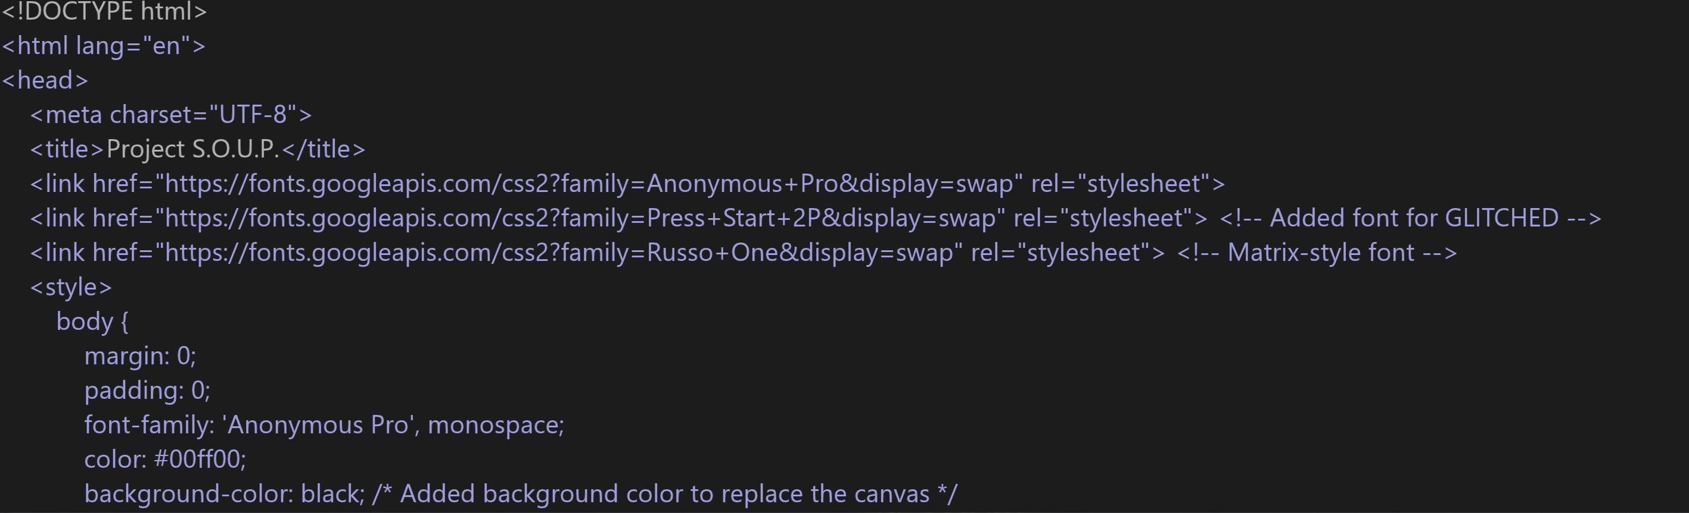

I created a main menu inspired by the Matrix. From the code, I was able to reference the same text font used from the movie. The text “GLITCHED” is animated, giving it that error look.

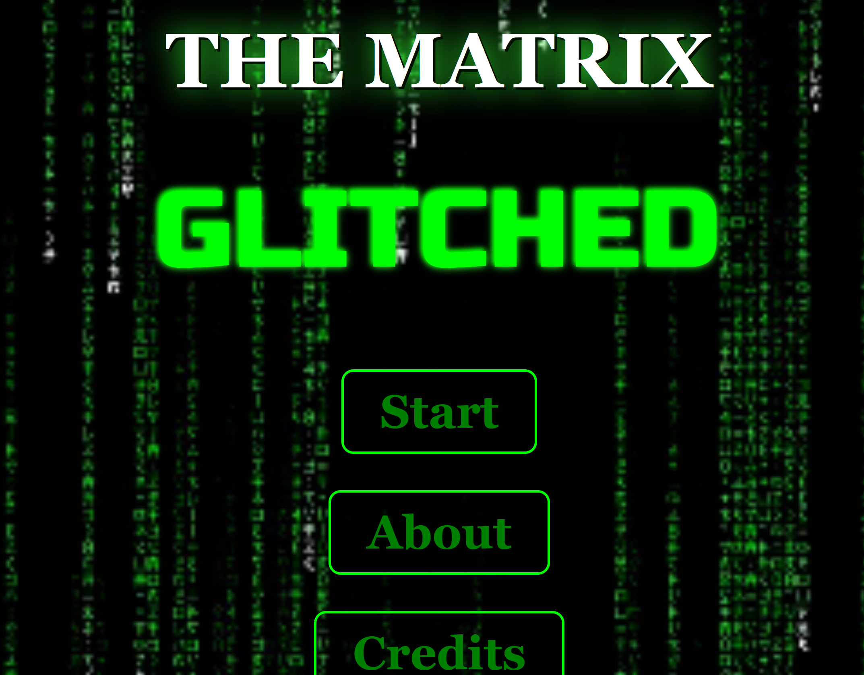

**Passages**

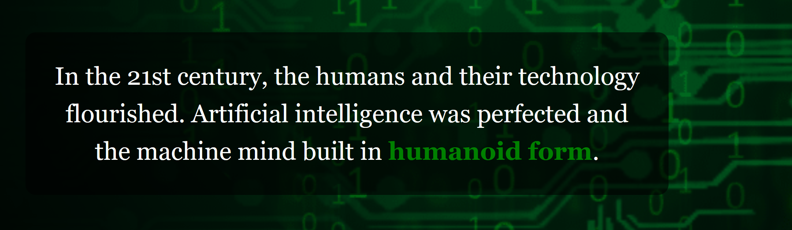

Moving from passage to passage was a very simple execution. I just had to add [[]] with text inside the brackets. The text would become a link (represented as green in the snapshot) that led into the next passage.

**Prompts**

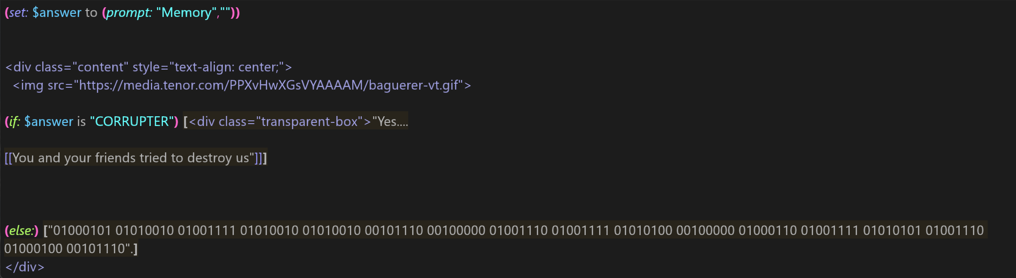

Prompts resemble the basic if/else statements that resemble Python code. If the player answers correctly, they can proceed. If the player gives the wrong answer, they cannot proceed and must try again.

From this, I was also able to create a “three strike rule” in which if the player failed to give the answer three times, he/she would have no choice but to proceed a different route.

**Backgrounds/Images**

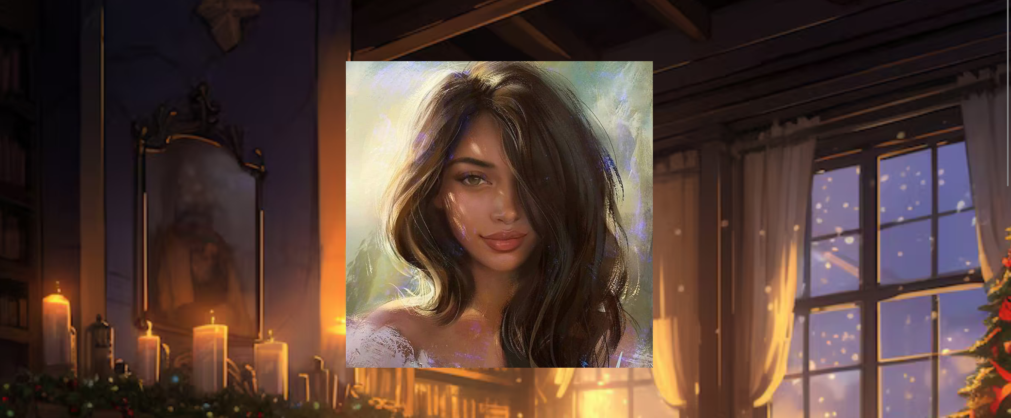

Backgrounds in Twine 2 can be made by implemented by applying this code in the stylesheet

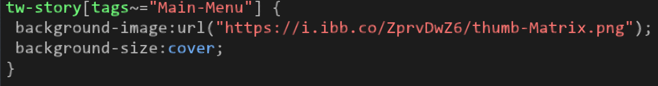

Each background was given a name. From this, I can call it as a “tag” in any passage I wanted



To add in an image, I used this simple line of code to draw from the internet. The width and height of the image can also be controlled.

**Semitransparent text box**

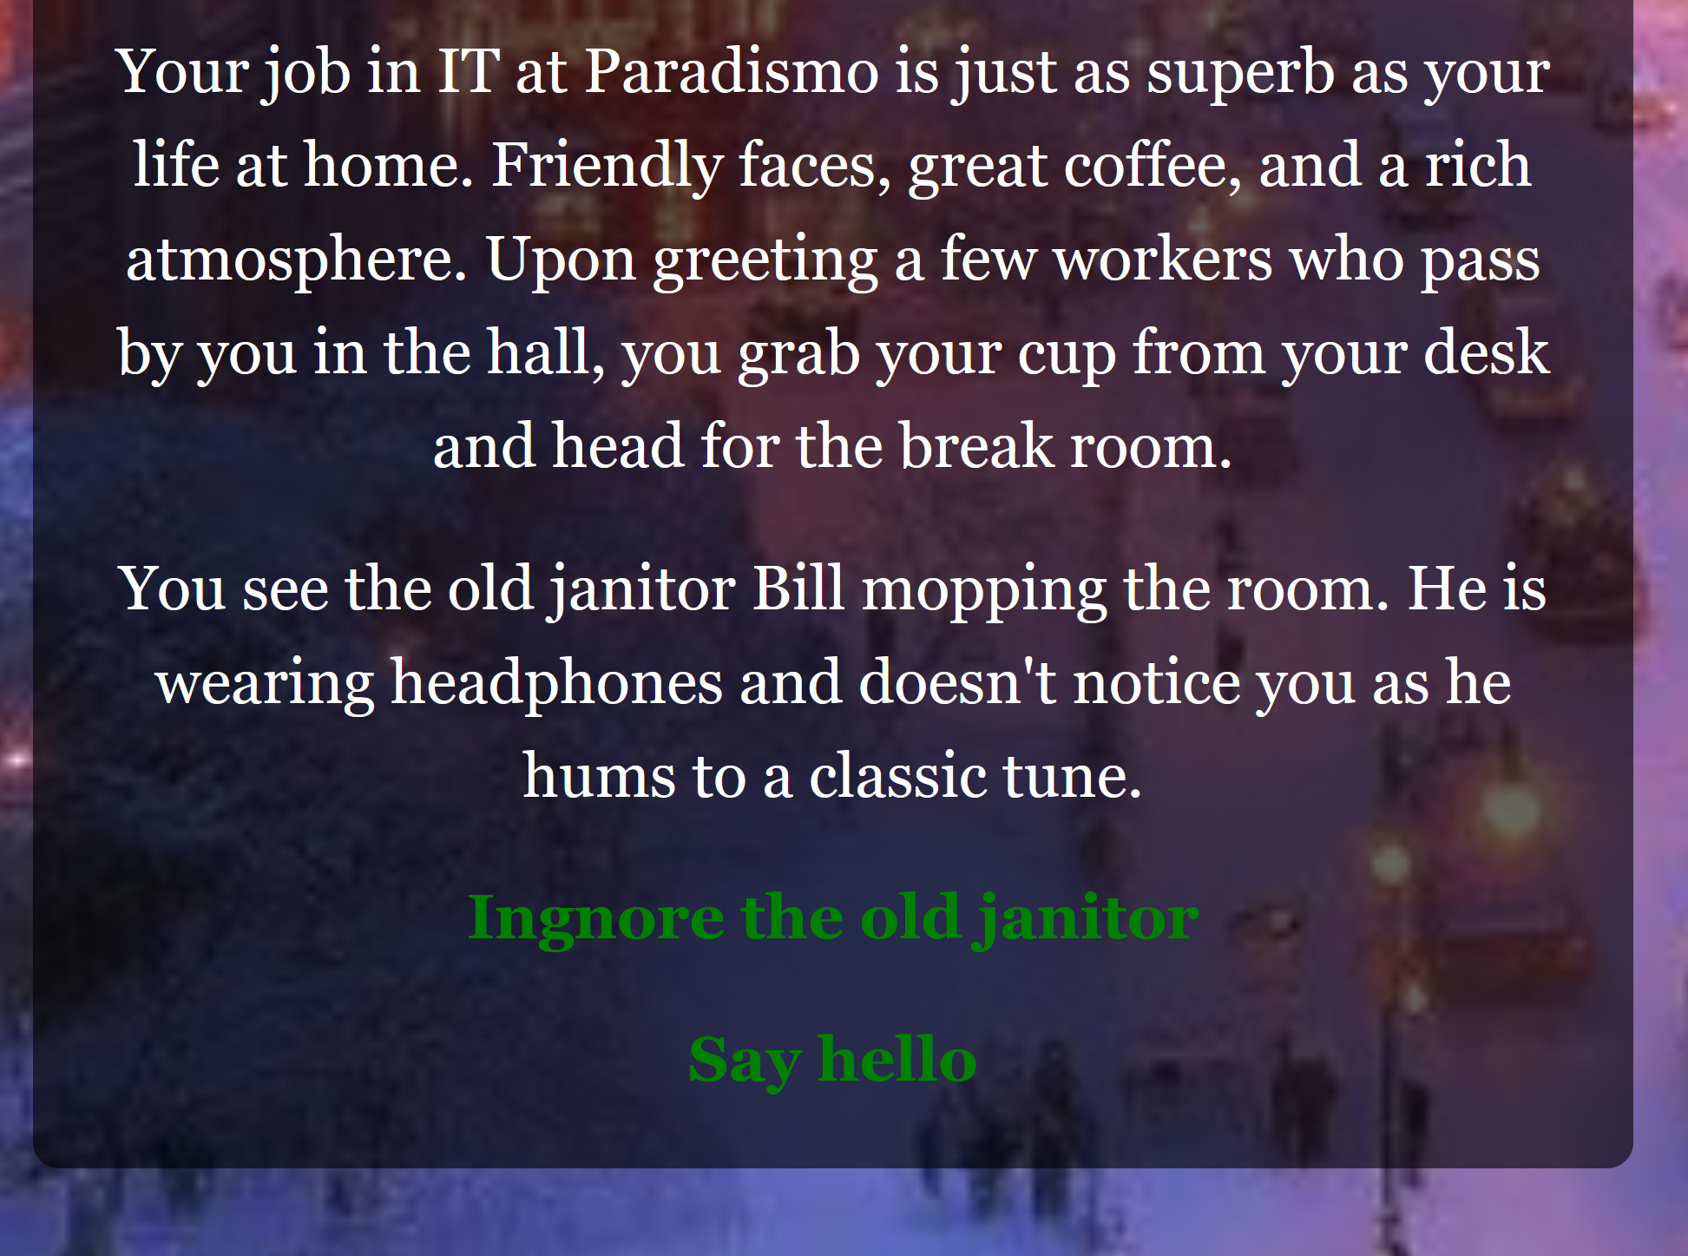

Using a text box was extremely effective due to some background images making it hard for words to be read. This was accomplished by using the following code:

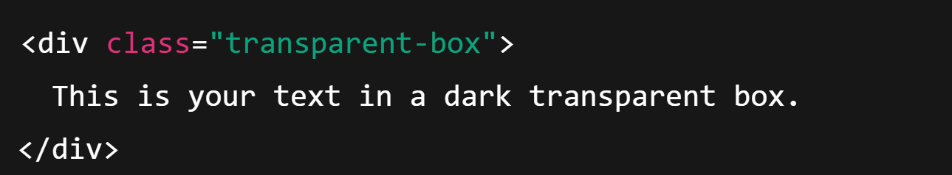

**Music**



To add music into my game, I could host music files on the Wix website and call on them in my passages using this code:



Incorporating music further helped to set the tone of the story in several instances.

**Testing/Result**

When testing the game, it ran decently. There may have been a few issues with the screen size or the music not being able to be heard on some computers. Overall, it worked as intended from beginning to end.

**Ethical, Legal, Security Considerations/Concerns**

There are no issues or concerns regarding this in my project.

**Project Performance, Uniqueness and Similarity to Others**

Project performance wasn’t as great as I hoped. Since I was working alone and not in a group as I hoped, I had to do everything and became overwhelmed. I was unable to do The Nightmare Matrix chapter. The Paradise Matrix had its own share of story issues. Things weren’t properly executed, but progress was achieved. Things would have been much, much easier had I just followed a story already written and implemented game mechanics/designs that way.

Compared to other students, my senior project was unique in terms of it being a story-driven game made from Twine. Similar aspects shared with other students are working with code. Fortunately, it wasn’t as complicated as theirs.

**Conclusion**

In conclusion, I created a interactive story game using Twine 2, a open-source tool. The game was called Matrix Glitched, a fanfiction based off the movie The Matrix that serves as a prequel. I summarized the design, mechanics, and code that helped me achieve most of my vision. The learning process made me realize just how frustrating it can be to create a game, even one as simple as this. It takes time and a great deal of teamwork, which I had none of the latter. The story will forever stick with me as I hope a prequel movie will be made one day or an actual video game.

**References**

“Twine Is an Open-Source Tool for Telling Interactive, Nonlinear Stories.” *Twine / An Open-Source Tool for Telling Interactive, Nonlinear Stories*, twinery.org/

“Matrix Wiki.” *Matrix Wiki*, matrix.fandom.com/wiki/Main_Page.

*Adam Hammond*, [www.adamhammond.com/twineguide/](http://www.adamhammond.com/twineguide/).

*YouTube*, YouTube, www.youtube.com/watch?v=iKFZhIHD7Xk&list=PLklITFhXtPCCKadv-0Gcbqoj3OCev695D.

Anable, Aubrey. *Playing with Feelings: Video Games and Affect*. University of Minnesota Press, 2018. *JSTOR*, https://doi.org/10.5749/j.ctt20mvgwg.